1. What is SDLC?

Software development life cycle is a structure that is impose on development on software

,they defined the process of planning, implementation, testing of deploy the maintenance of

support.

2. What is software testing?

Software testing is a process use identify of correctioness, completeness and quality of

develop software.

3. What is agile methodology?

Agile is a Sdlc module is combination of iterative and incremental and adaptivable on customer satisfaction on development in software.

4.What is SRS?

Software Requirement Specification(SRS) is a document that describes what the software will do and how it will be expected to perform.

5.What is oops?

Object Oriented Programming System.

Identifying object and assigning responsibilities to this object.

6.Write Basic Concepts of oops?

1.Class.

2.Object.

3.Encapsulation.

4.Inheritance.

5.Polymorphism.

7.What is object

Object is a instances of an class to create memory for that class to access all the properties of an class expect private

Sy:

{

Classname objectname=new classname();

}

8.What is class?

Class - is a collection of data member (Variable) and member function (process, methods) with its behaviour is called Class

Sy :

Class classname

{

Datamember

Member function

}

9.What is encapsulation?

Data hiding - wrapping up of data into single unit.

Private your data member and member function.

10.What is inheritance?

Inheritance - properties of parent class extends into child class.

MAIN PURPOSE - Extensiblity, reusability.

11. What is polymorphism?

Polymorphism - ability to take one name having different forms ; Multiple forms.

12. Draw Usecase on Online book shopping

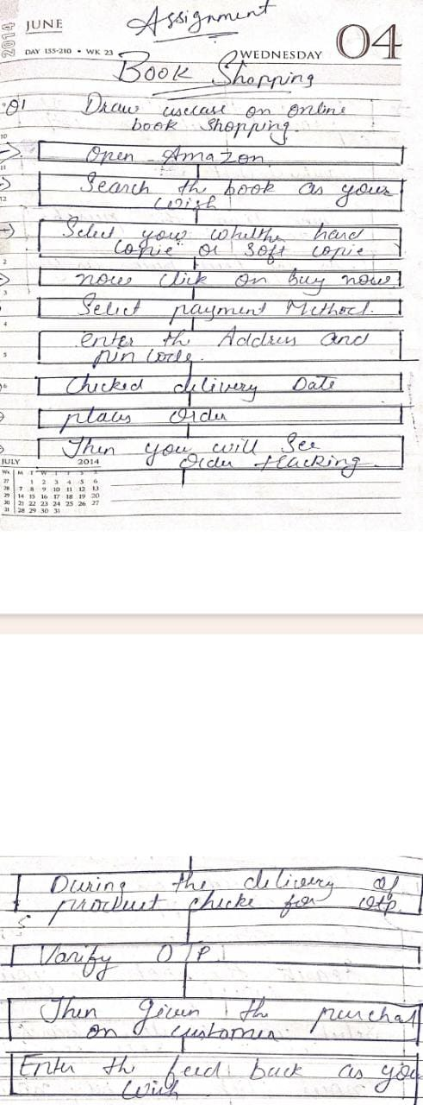

13. Draw Usecase on online bill payment system (paytm)

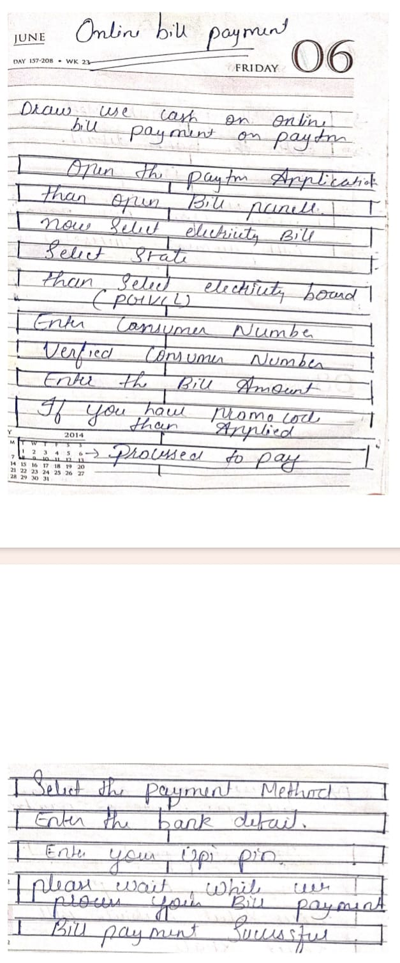

14.Write SDLC phases with basic introduction?

Software development life cycle are phase is given below:-

1.Requirement :-

Establish customer needs and they requirement basic needs in document of the software.

Requirement can be upon customer depend in the development

2.Analysis:-

They have to checked that what requirement have in the analysis and what to do.

3.Design:-

Modify and specify “why”.

Design and implement of the structure scenario of the customer verification

Implementation :-

This is phase that they have do work with the team building and idea.

What to do and what are result they depend on team work.

4.Test :-

Testing case are more importance in the companies have to get great quality are more

importance

Companies they have to get solution in lower quality testing.

5.Maintenance :-

Maintenance is the process of changing a system that they deploy.

1.Corrective maintenance.

2.Adaptive maintenance.

3.Perfective maintenance.

15• Explain Phases of the waterfall model

1.Requirement

2.Analysis

3.Designs

4.Implementation

5.Test

6.Maintenance

Water model is one type of model.

They have frozen in early in software

This is a short term project.

PROS:

Easy to tasks.

Simple and easy to use.

Easy to manage due to high rigidity.

Cons:

High amount to certainity risk.

Not good model for long ongoing project.

Not flexible project.

16• Write phases of spiral model

There are four phrase :-

1. Planning

2. Risk analysis

3. Engineering

4. Customer Evaluation

17•Write agile manifesto principles

Agile Manifesto are :-

1. Individual interaction

2. Working software

3. Customer collaboration

4. Respone to change

18• Explain working methodology of agile model and also write pros and cons.

Agile sdlc model is combination in iteration and incremental in process of adaptability on

customer satisfaction in rapid delivery on development.

19• Draw usecase on Online shopping product using COD.

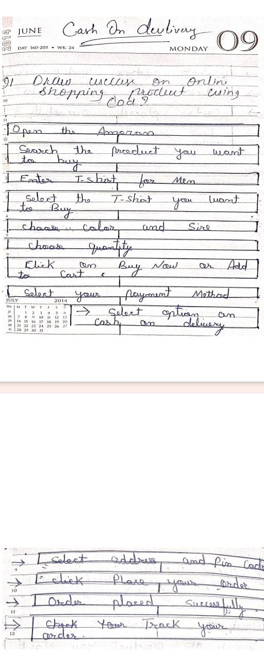

20• Draw usecase on Online shopping product using payment gateway.

